**Snow Plow Audit, Report**

The goal of the present report and work detailed herein is a summary of the extent of pavement present in Princeton Landing, New Jersey for the purpose of estimating the cost of snow plow services in the community (i.e., a “snow plow audit). The work is conducted on behalf of Forrestal Village Community Services Association, Inc., the neighborhood association of Princeton Landing (i.e., the “Association”) as an independent consultant (i.e., the “Consultant”) under no influence of the Association. The work is completed based on objective evidence of where paved surfaces are located in the community as detailed herein.

The Consultant, Geoffrey Fouad, PhD, holds a doctoral degree in the type of work expressly performed here (i.e., mapping features based on aerial imagery), and has a total of 16 years consulting experience as a geographer, performing scientific investigations for entities such as the federal government (e.g., the United States Geological Survey), state government (e.g., the New Jersey Department of Environmental Protection), and local government (e.g., Bridgewater Township, New Jersey). In such roles, Dr. Fouad is required to perform objective scientific analysis on behalf of clients and deliver results which account for resources, assets, and conditions on the ground which reflect reality. For more information, the reader is directed to the abbreviated, one-page consulting resume of Dr. Fouad (see Appendix A).

The report follows by outlining the location of the study (see Study Area) and the methodology of how pavement in the study area of Princeton Landing is mapped (see Methodology). The results of this process are then detailed in a series of figures (visual evidence of pavement) and a table summarizing the area of pavement in Princeton Landing for the purpose of estimating snow plow costs (see Results). The costs are not estimated here as the rate of plowing per unit area is not supplied and no doubt varies by plowing service. For this reason, the evidence presented here can be used in the application of estimating snow plow costs. This evidence is supplied in the results and by way of an online map for the interactive inspection of pavement hosted at:

<https://geoffreyfouad.github.io/Princeton_Landing>

**Study Area:**

Princeton Landing, New Jersey is a master-planned community situated across Carnegie Lake from historic Princeton, New Jersey where of course the world famous Princeton University is located. The community is wedged between Carnegie Lake (to the west) and US Route 1 (to the east) at Sayre Drive in the 08540 zip code, and is parceled (subdivided) into 12 parcels, which are the subject of this pavement inventory as they are subject to plowing and require cost estimates of such a service dependent on the area of pavement in the 12 parcels (Figure 1).

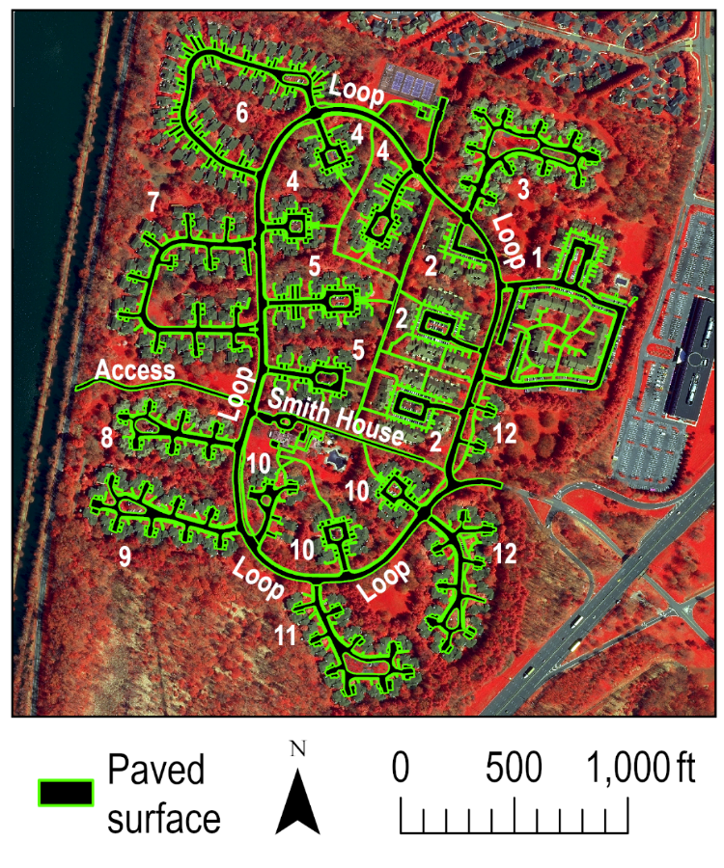

**Figure 1.** Map of Princeton Landing, New Jersey labeled by its component parts of Princeton Landing parcels (12 total) subject to a snow plow audit and pavement mapping analysis in which the pavement in each parcel and common community area, including the loop and access roads and Smith House area, is mapped.

As defined by New Jersey state tax parcels (available at <https://njgin.nj.gov/njgin/edata/parcels/>), the entire extent of the Princeton Landing development is 0.21 square miles (or 5,929,929 square feet to place that extent into the units of the pavement mapping), including the common areas of the loop drive, access road, and Smith House recreational area (see Figure 1). It is important to note that the “parcels” used by the community are not equivalent to the parcels of the state tax map. For accounting purposes here, the state tax parcels belonging to a Princeton Landing parcel are coalesced to form the accounting area for each parcel of Princeton Landing. This is a necessary means to follow state tax allotments, and in practical terms of this analysis, it determines the extent of a Princeton Landing parcel relative to where it meets the loop road (see boundaries between the loop road and adjacent parcels in Figure 1). Because the margins (surroundings) of the community are wooded and not paved, the parcel boundary definition did not play a role in these parts of the study area, and only played a role in defining the extent of each parcel relative to the loop road.

**Methodology:**

The methodology applied here is chosen based on a careful comparison of increasingly manual (less automated) and more time-consuming (costly) approaches as outlined in the scope of work (see Appendix B). It was ultimately determined to proceed with the entirely manual mapping approach as it most realistically maps pavement in the community and follows the predictable design patterns of the master-planned development. This methodology uses the aerial imagery officially issued by the State of New Jersey at <https://njgin.nj.gov/njgin/edata/imagery>. The particular image used is the latest for the study area collected in a period with fewer leaves on trees (the so-called “leaf-off” imagery) in the year 2020. The months of this survey are in April and May of that year, and the “tile” (area) of imagery for Princeton Landing was downloaded from the state’s interactive web map on December 29, 2023. The file downloaded is from the tile named “G10B10,” and is supplied in a MrSID compressed file format for unpackaging on the local machine of the analysis where the resolution of the mapping was conducted in one-square-foot “pixels” (square grid cells on the ground) at a mapping resolution of 1 to 300 (e.g., one inch on the monitor is equivalent to 300 inches on the ground) in the New Jersey State Plane mapping coordinate system using the geographic (round earth) coordinate system of the North American Datum (NAD) of 1983 updated in the year 2011. This is both the standard coordinate system and grid cell size of imagery supplied by the State of New Jersey. For exact documentation of the image used in this analysis, please find the metadata located at:

<https://newjersey.maps.arcgis.com/sharing/rest/content/items/b88ef621b3544b74a4d1801ded64a84e/info/metadata/metadata.xml?format=default&output=html>

The mapping delineated paved surface according to their extent depicted in the aerial imagery, and for accounting purposes, those surfaces were subdivided into street (asphalt throughways for vehicle use), driveways (cement or aggregate surfaces for parking vehicles and entryways to garages), and finally sidewalks made of similar material as driveways, but for the express purpose of walking in the community. This way a snow plow audit can subdivide costs based on these different forms of pavement. Pavement of different types that share a border have that topology (i.e., the fact that they share a border) enforced by way of a special tool known as “auto complete polygon” which forms a seamless border between neighboring (adjacent) features. This ensures adjacent units of pavement of different types share a seamless border as is topologically correct. In cases of overhead obstructions, such as tree cover or shadows, secondary evidence of the extent of pavement is applied, which includes the use of Google Street View and also plans as depicted in engineering design schematics of the community. This way pavement matches what is shown in the imagery and also what is known to exist on the ground according to the neighborhood’s design. The mapping was conducted in ArcGIS Pro software using the same software layout throughout on a 32-inch Samsung EH4003 monitor in which no settings were changed the entire time. The image was displayed in a false color composite as shown

throughout the figures in this report and in the interactive online map in order to highlight the extent of pavement relative to vegetation. The combination of bands which best distinguished pavement is near infrared illuminated as red, red illuminated as green, and blue illuminated as blue for the appearance of vegetation in red and pavement in varying contrasting hues distinct from vegetation. This outlines the methodology of the pavement mapping in a way that is reproducible for repeating this procedure and obtaining similar results.

The work outlined and written here spanned 25 billable hours completed in two full days of mapping (16 hours), plus another two hours of quality control on a third day, a fourth and fifth day of writing this report (seven hours), and two hours on the fifth/last day of packaging/documenting the data deliverable (see Data Deliverable), all completed in the time span between January 2 and January 8 of 2024 (see the Invoice).

**Results:**

The results begin with a summary of the area of pavement subdivided by parcel (or common area) and the type of pavement (Table 1). This is an inventory of the pavement and its type by parcel for the purpose of estimate snow plow costs. What should be noted is that because snow plows presumably do not plow in parking spaces where cars are parked and where cars can be damaged, the small areas comprising parking spaces along streets are not included in the street measurements of pavement. This is purely for practical reasons in that they would not be subject to plowing and thus would not account for snow plow costs. If they were added to the extent of paved streets, the addition would be negligible compared to the entire extent of streets in Princeton Landing. The totals of paved surfaces are supplied by parcel and also for the entire community as this is presumably the most important column for estimating snow plow costs if they do not vary by pavement type (i.e., costs could be estimated based on the total column alone). The measurements presented here are in square feet as has been done in previous works to map pavement in the community of Princeton Landing.

**Table 1.** Pavement by parcel in square feet (ft2) subdivided by type and totaled (see last row and column) for the Princeton Landing community completed for the purpose of estimating snow plow costs (the last column of totals is likely most relevant for that).

|  |  |  |  |  |
| --- | --- | --- | --- | --- |
| Parcel | Street | Driveway | Sidewalk | Total |
| 1 | 64,291 | 0 | 29,230 | 93,521 |
| 2 | 36,999 | 0 | 19,731 | 56,730 |
| 3 | 52,078 | 11,642 | 9,097 | 73,804 |
| 4 | 34,122 | 21,351 | 21,537 | 77,010 |
| 5 | 30,163 | 20,030 | 14,204 | 64,397 |
| 6 | 38,927 | 32,501 | 15,837 | 87,265 |
| 7 | 61,735 | 12,577 | 14,899 | 89,211 |
| 8 | 28,906 | 7,189 | 6,259 | 42,354 |
| 9 | 37,462 | 9,338 | 8,718 | 55,518 |
| 10 | 33,132 | 14,718 | 9,708 | 57,558 |
| 11 | 39,010 | 10,173 | 8,358 | 57,541 |
| 12 | 41,930 | 13,307 | 8,623 | 63,860 |
| Smith House | 20,351 | 0 | 10,188 | 30,539 |
| Access | 14,468 | 0 | 0 | 14,468 |
| Loop | 175,526 | 0 | 39,032 | 214,558 |
| Total | 709,100 | 152,826 | 216,408 | 1,078,334 |

The maps that follow are evidence of pavement in Princeton Landing parcels one through twelve (see Figures 2 to 13), omitting common areas of the loop and access roads and the Smith House as those areas are shown in Figure 1 and they are parsed from parcel totals as shown in Table 1.

The pavement of Princeton Landing parcel one includes streets for access to parking and sidewalks for access to parking and entry/exit from apartment buildings (Figure 2). This excludes driveways as they are not part of the development in this parcel. The streets ring the apartment buildings as do sidewalks and a street extends in the shape of a letter “n” to provide access to apartment buildings at north, as do sidewalks. Sidewalks are spaced at predictable intervals to apartment buildings and this is verified by Google Street View. At the interior of the largest configuration of apartment buildings are sidewalks which provide access to a shared, common courtyard, and these sidewalks can be excluded from the total if they are not subject to plowing.

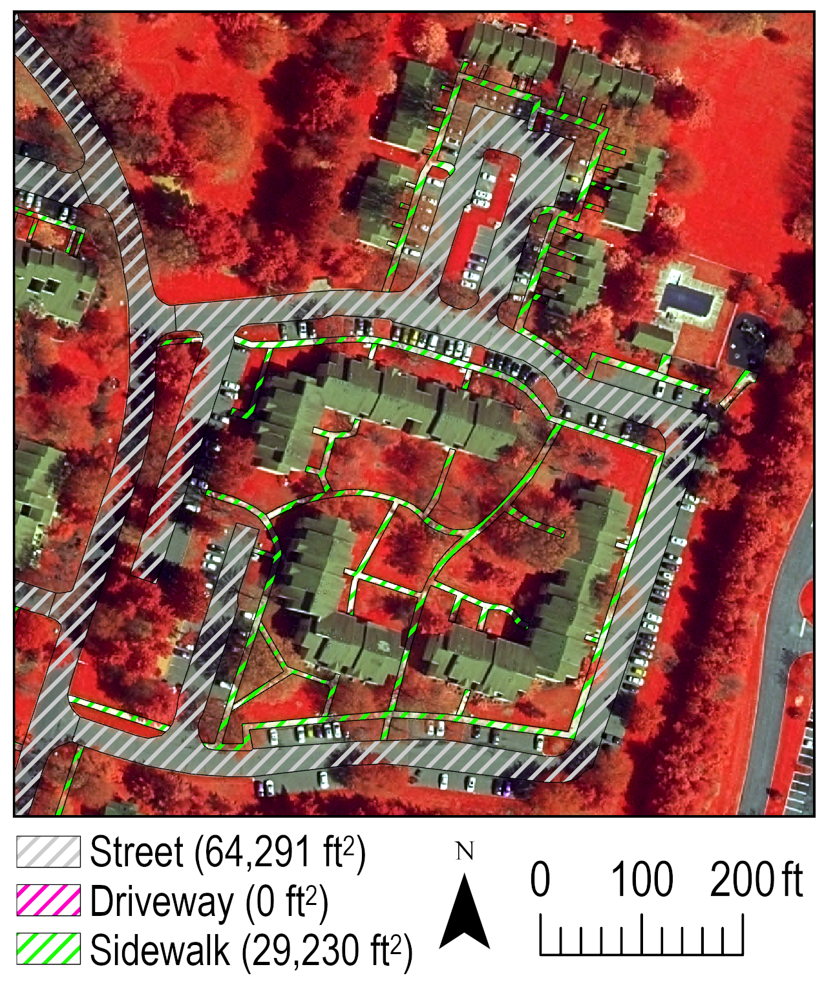

**Figure 2.** The extent (square feet in parentheses) of pavement in Princeton Landing parcel one.

Princeton Landing parcel two is much like the first parcel presented in not having driveways, and rather has the style of an apartment complex where the vehicle pulls into a parking space (not subject to plowing). The parking spaces are naturally served by paved streets and sidewalks, which extend to the entry ways of the apartment buildings (Figure 3). The entire extent of parcel two is divided into three smaller parts, each having a street entry/exit to the loop road, and two of which in the case of one part of this development (see the map at left in Figure 3). From there, streets extend in what amounts to a loop servicing parking spaces, which are in turned served by sidewalks that ring the streets and sidewalks which lead to apartment buildings). The sidewalks to apartment buildings required confirmation by Google Street view and the extent of which are mapped according to the front of apartment buildings visible in the aerial imagery. Sidewalks in this part of the development also lead to common areas between two of the apartment complexes (see the sidewalk pictured at bottom of the middle map in Figure 3 which is also shown at top of the right map of the same figure), and also to a long extent of sidewalk that splits parcel two from parcels four and five (see Figure 1). The long extent of sidewalk that splits these parcels is mapped separately and assigned to the loop road sidewalk as it does specifically serve any one parcel of Princeton Landing.

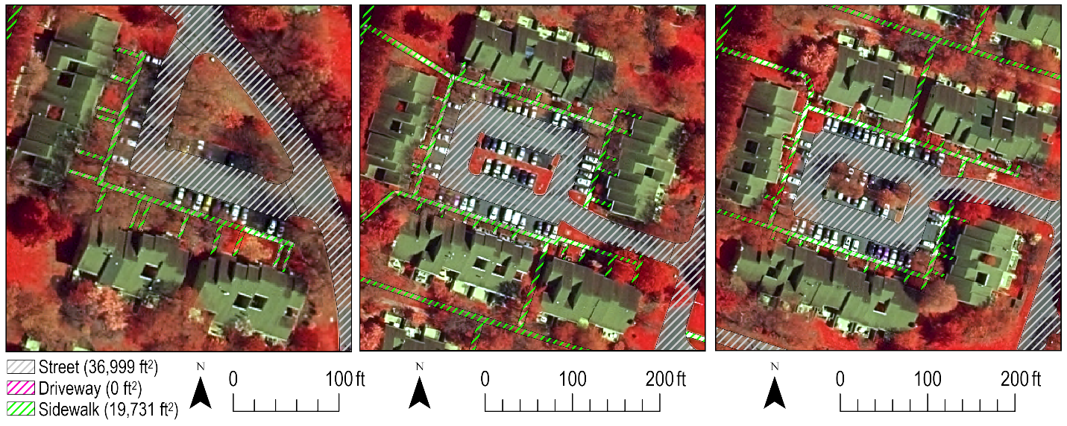

**Figure 3.** The extent (square feet in parentheses) of pavement in Princeton Landing parcel two.

Parcel three is the first that includes driveways and these are serviced by small feeder streets (or inlets of sorts) which lead to the driveways, connecting the driveways to the outlet street that eventually connects this parcel to the loop road (Figure 4). The driveways are divided for each residence, reflecting a narrow strip of vegetation that separates driveways of different residences and respective garages. Although on occasion, the exact width of the vegetated strip between driveways is not visible from above in the aerial imagery, its presence is confirmed by way of Google Street View and the width is assumed based on the width of other vegetated strips more clearly visible in the imagery. The end of inlet streets to driveways can be obscured by vegetation at the end of the street, but its shape/extent is assumed to be similarly designed throughout the parcel and this is confirmed via Google Street View in mapping the ends of street inlets. Sidewalks follow the street leading to the loop road, and progress to front entrances of residences, which are largely visible in the aerial imagery, but still confirmed throughout the parcel by way of Google Street View observations. Driveways and sidewalks are observed to consume about the same area as each other, and the street extent is about five times larger than either driveways or sidewalks, illustrating the importance of accurately mapping streets in the process of estimating snow plow costs.

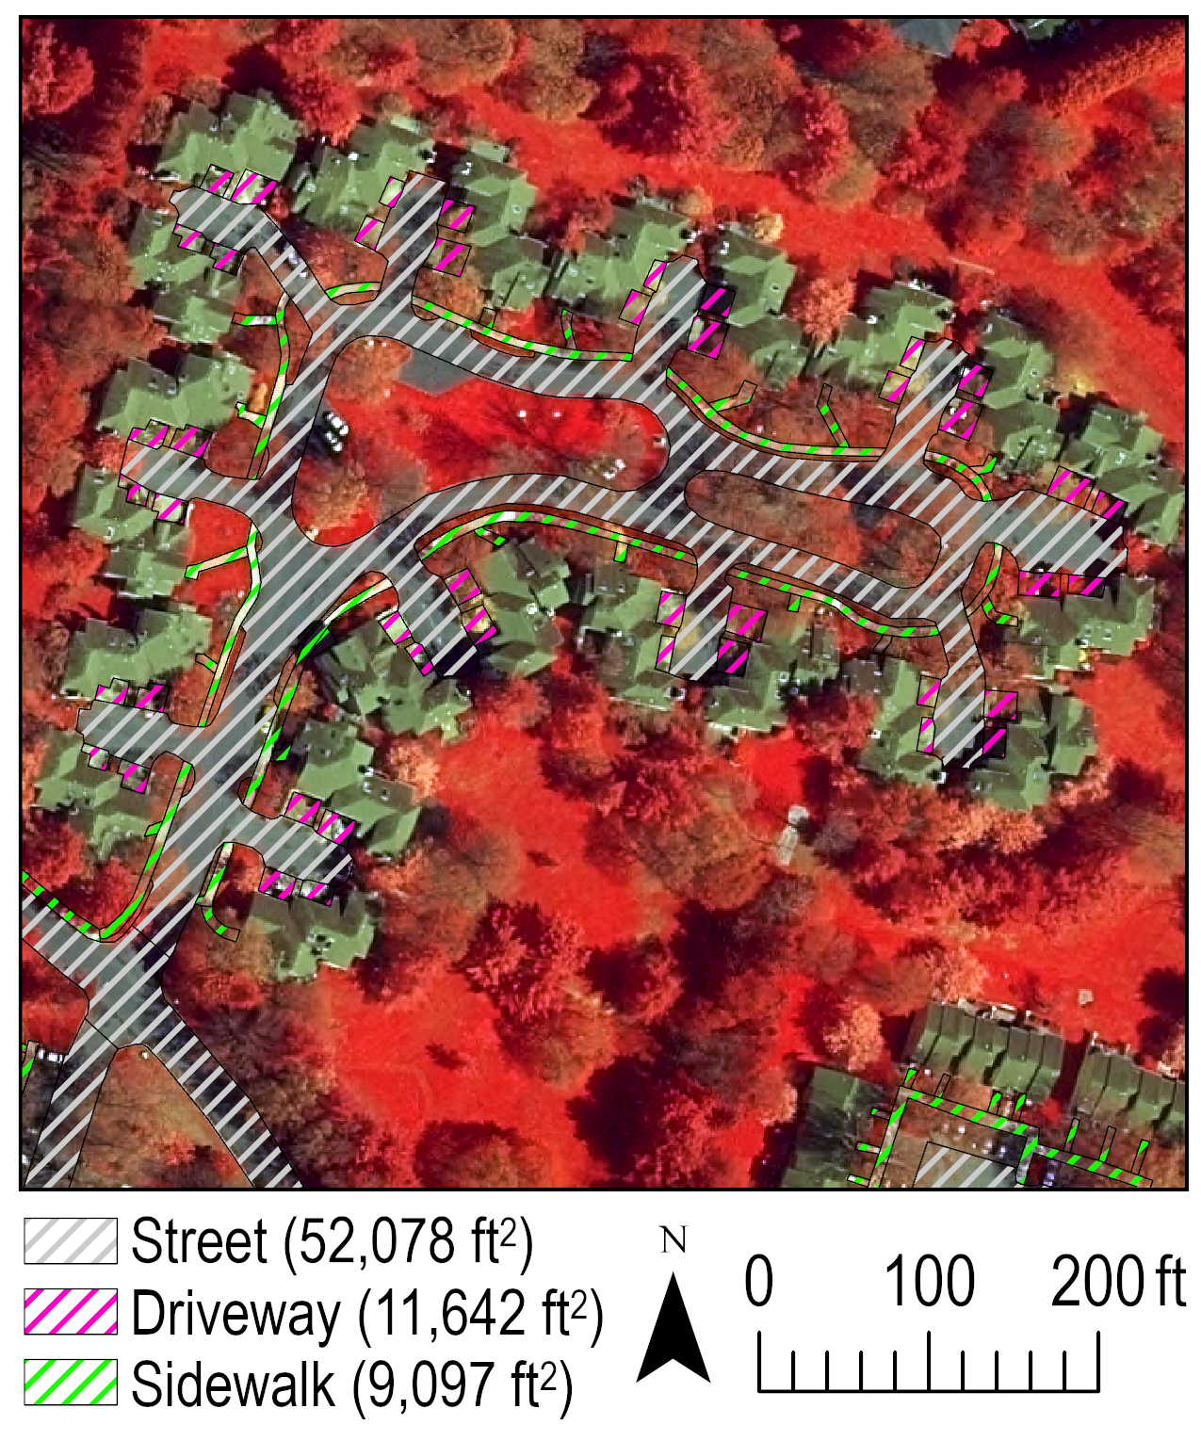

**Figure 4.** The extent (square feet in parentheses) of pavement in Princeton Landing parcel three.

Parcel four follows a new development design not observed in prior parcels presented. This design includes a single street directly connecting driveways to the loop road (Figure 5). From a mapping perspective, this means driveways intersect sidewalks before entering the main street exiting to the loop street. This is treated as one continuous driveway from the garage of the residence to the street as it serves the function of conveying a vehicle from the street to the garage, and thus is distinct from a single-purpose sidewalk (as is present between driveways). Thus, driveways connect garages to the street, and sidewalks connect driveways and provide a walkway from driveways to the loop road where the sidewalk continues around the loop road. Sidewalks also wrap around the side of a residence, connecting the driveway to a door into the residence. This is present at what might be described as end units where the driveway does not provide direct access to a door. In addition to this, sidewalks traverse from the loop road and each part of parcel four to the shared sidewalk that travels between parcels four and two (see Figure 1). Since these sidewalks are exclusive to parcel four, they are assigned as such until they reach the shared sidewalk between parcels four and two.

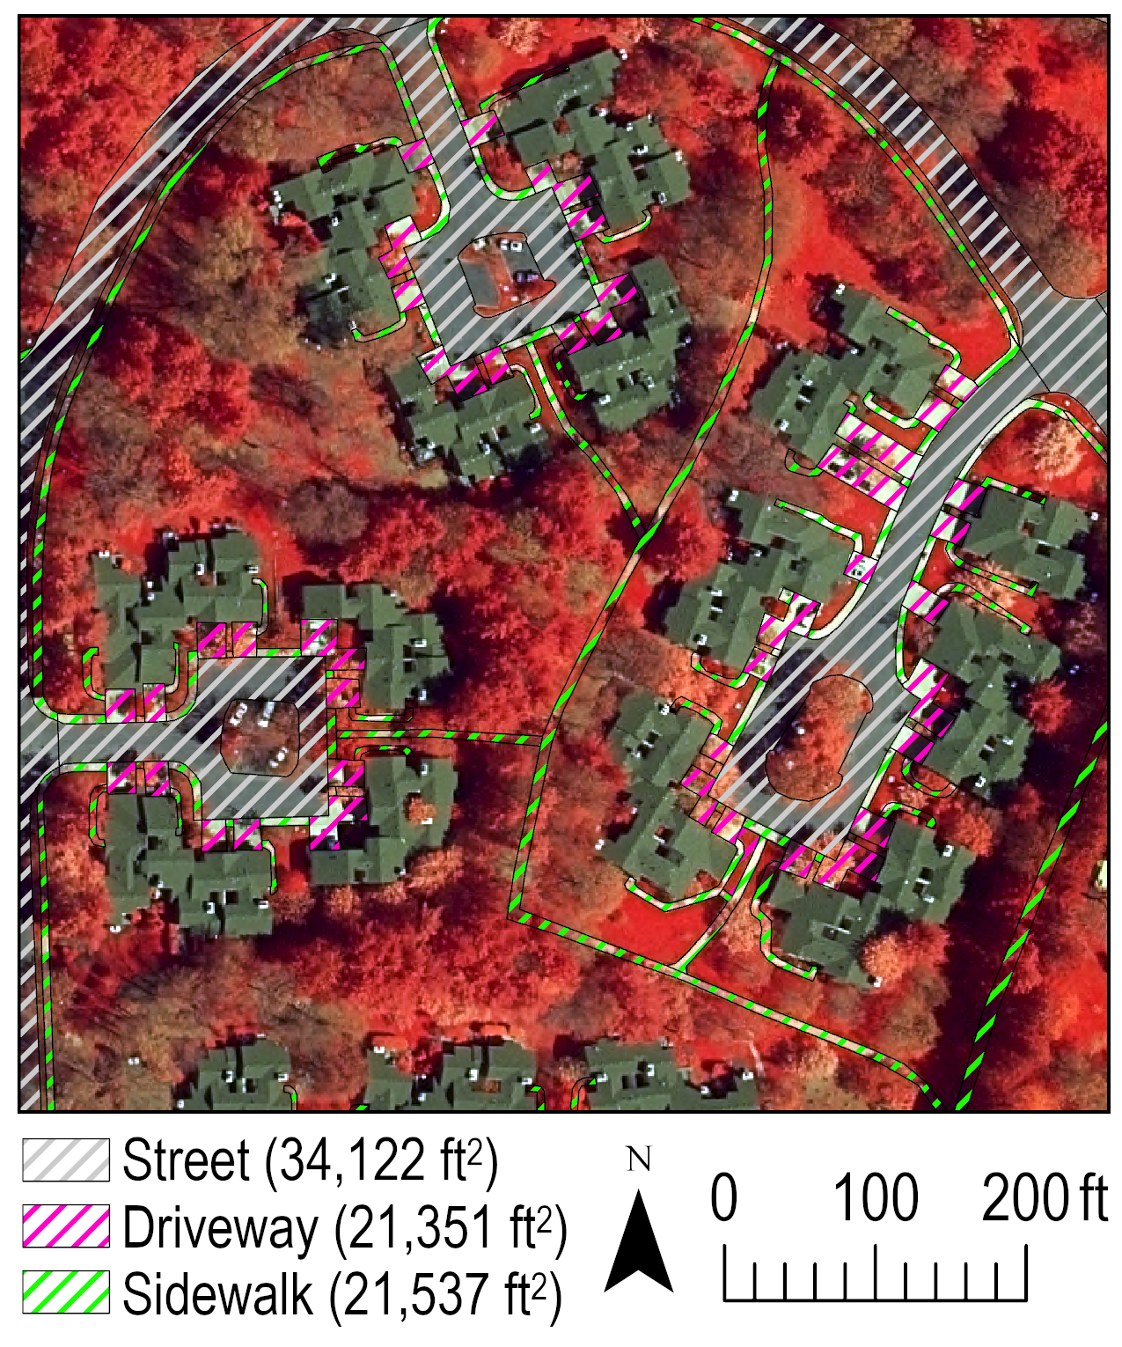

**Figure 5.** The extent (square feet in parentheses) of pavement in Princeton Landing parcel four.

Parcel five extends to two streets and is designed much like parcel four (Figure 6). The description of the configuration of driveways and sidewalks is the same as parcel four where driveways connect garages to streets and sidewalks connect driveways and serve as a walkway to the sidewalks of the loop road. Sidewalks also wrap around residences from driveways to doorways in a similar way as parcel four, except these sidewalks are present at each residence as compared to only end units in parcel four. Sidewalks in parcel five shown in Figure 6 also provide access to the sidewalk that splits parcels five from two to the east at the right of Figure 6. The sidewalks from parcel five to the common sidewalk that splits the parcels are assigned to parcel five, but the sidewalk that splits the parcels is assigned to the loop road as it is a resource shared by different parcels.

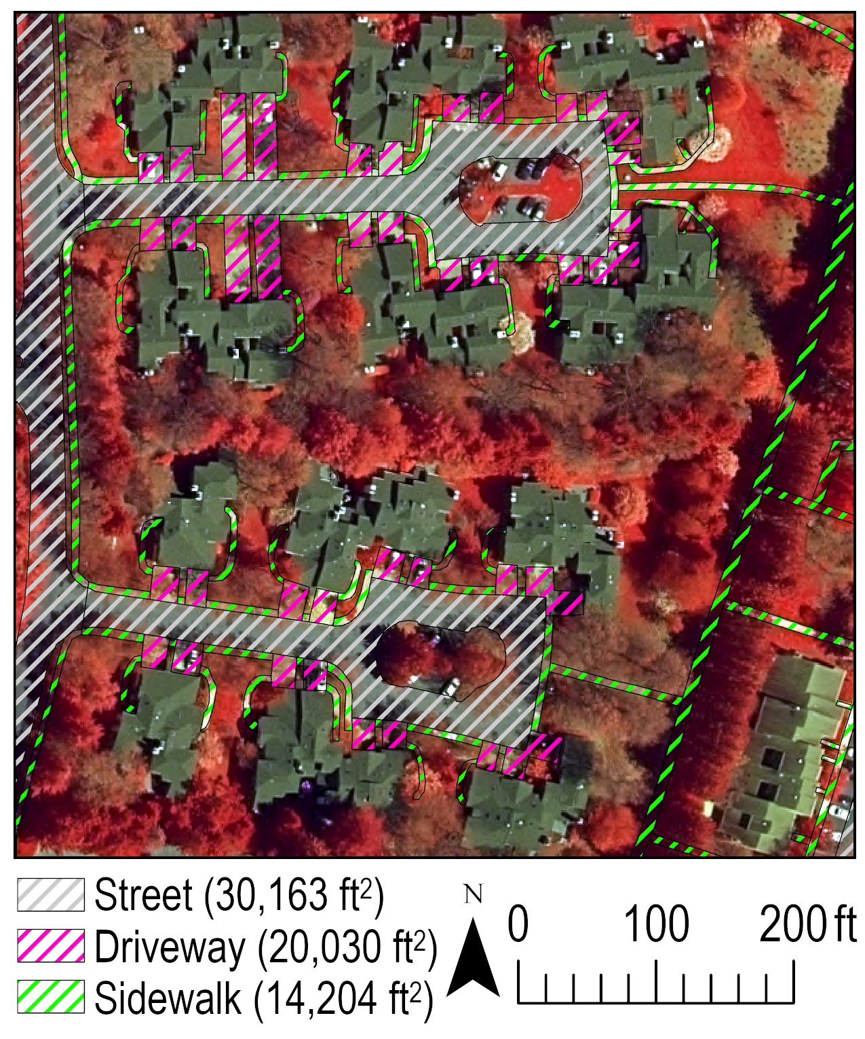

**Figure 6.** The extent (square feet in parentheses) of pavement in Princeton Landing parcel five.

In parcel six, we see a similar development design as in parcels four and five, except residences are setback farther from the street and this results in longer driveways (Figure 7). This does not change the design in having driveways connect streets to garages. Common sidewalks that travel between driveways and from driveways to the sidewalk of the loop road. Private sidewalks between driveways and doorways of residences are present at the side of each residence, and this confirmed by Google Street View as well as readily apparent in the aerial image at a scale at which the pavement is mapped (i.e., 1:300).

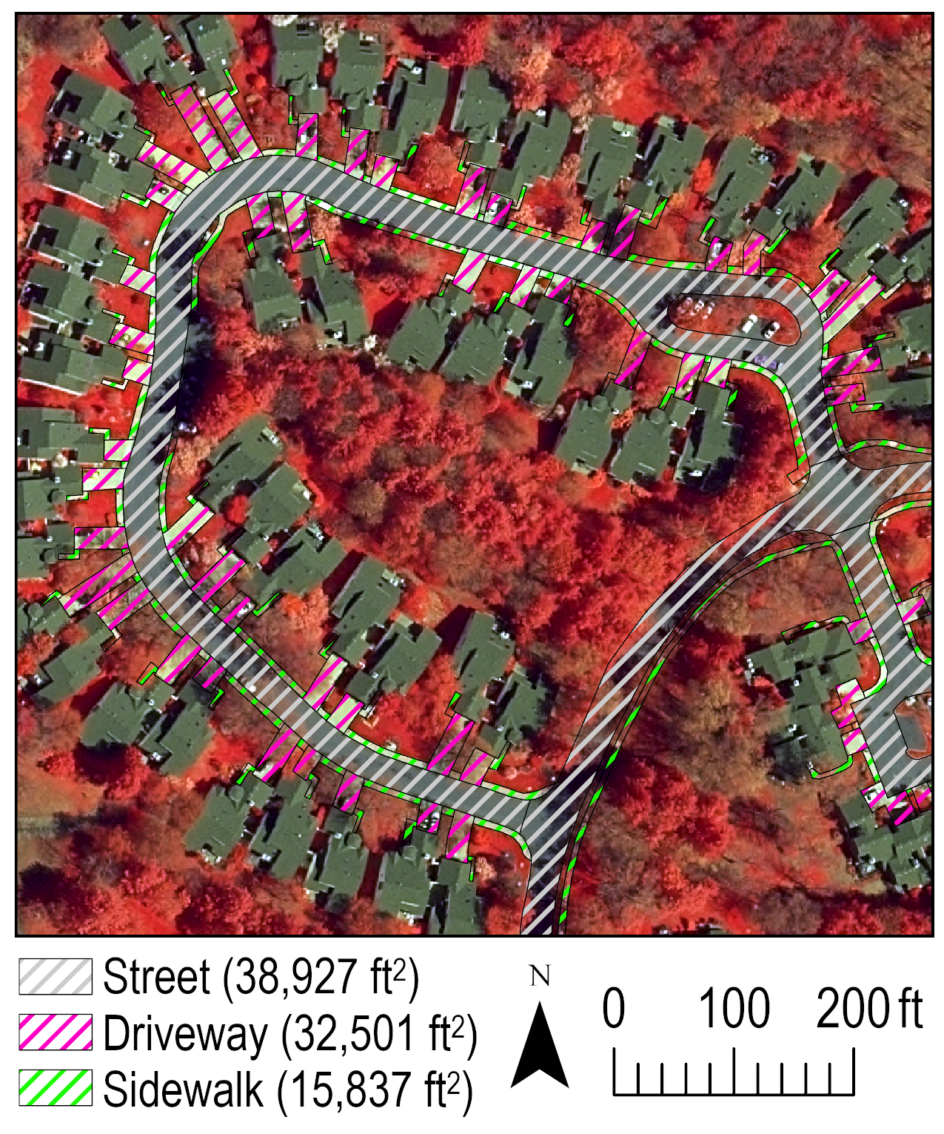

**Figure 7.** The extent (square feet in parentheses) of pavement in Princeton Landing parcel six.

The design of parcel seven follows a similar pattern as that in parcel three (Figure 8). There is a main street that serves as access to the loop road accompanied by smaller “inlet” streets that serve to access driveways into garages. Each inlet street has between three and four driveways depending on the number of residences, and the existence of these driveways is verified by Google Street View. Driveways are split between residences by clearly visible planting strips of vegetation, and this is further confirmed by Google Street View. Sidewalks ring the main street that provides access to the loop road, and these sidewalks provide access to select residences. The entryway to other residences is supplied by the pavement of the driveways, but because the pavement of these areas could not be distinguished from the driveways, they are combined here, which should not be an issue as plowing of these areas would not require different costs, and therefore do not need to be distinguished.

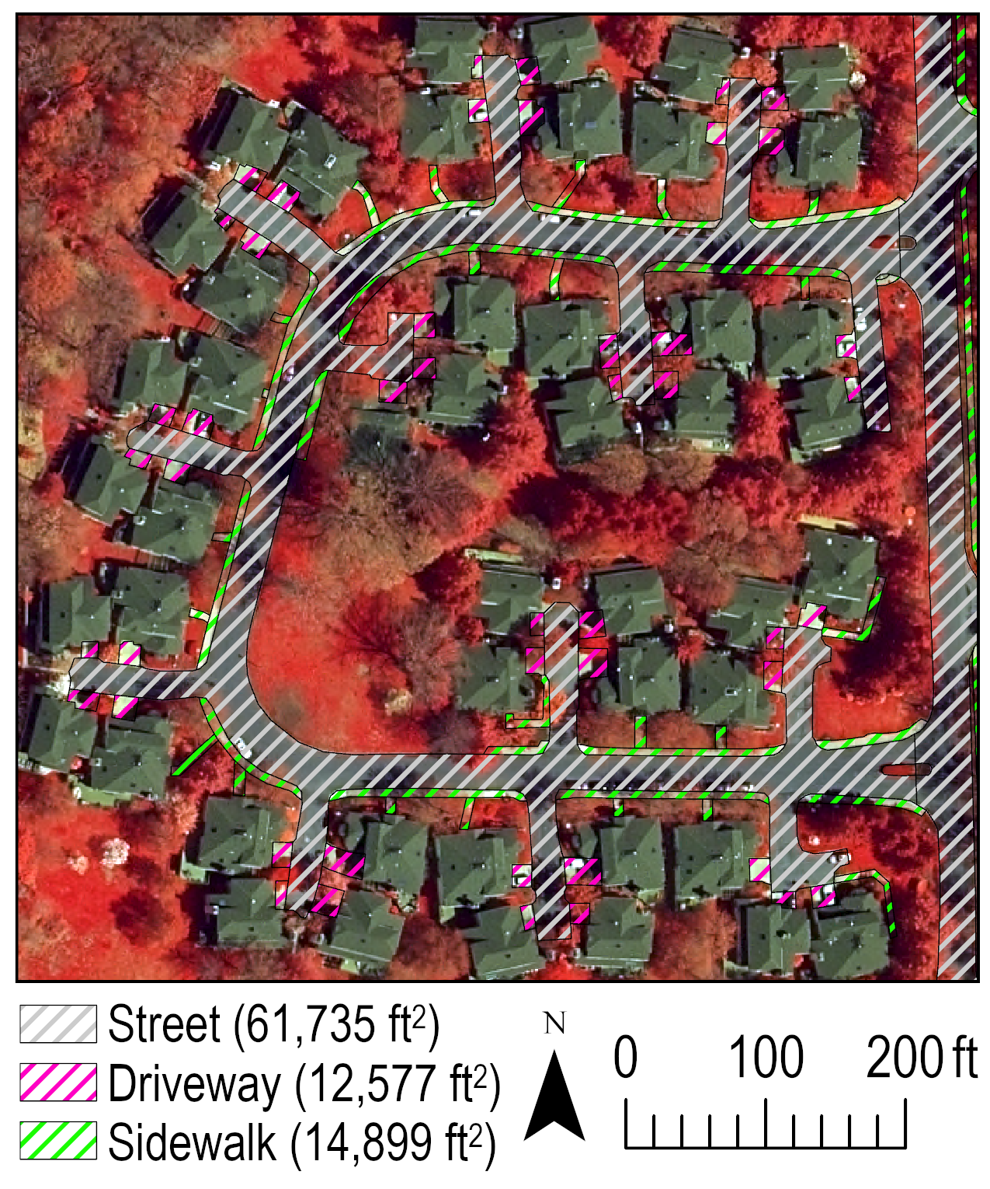

**Figure 8.** The extent (square feet in parentheses) of pavement in Princeton Landing parcel seven.

Parcel eight follows the design pattern of parcel seven on a smaller scale (Figure 9). A main street providing access to the loop road is accompanied by small “inlet” streets which provide access to driveways that lead to garages. Driveways are split between residences by small planting strips of vegetation and sidewalks ring the main street and also provide access to a select few residences, whereas those without sidewalks have entryways combined with driveways as is done in parcel seven with the same rationale that this pavement of driveway and entryway to a residence does not need to be distinguished, nor can it be, for the purpose of estimating snow plow costs.

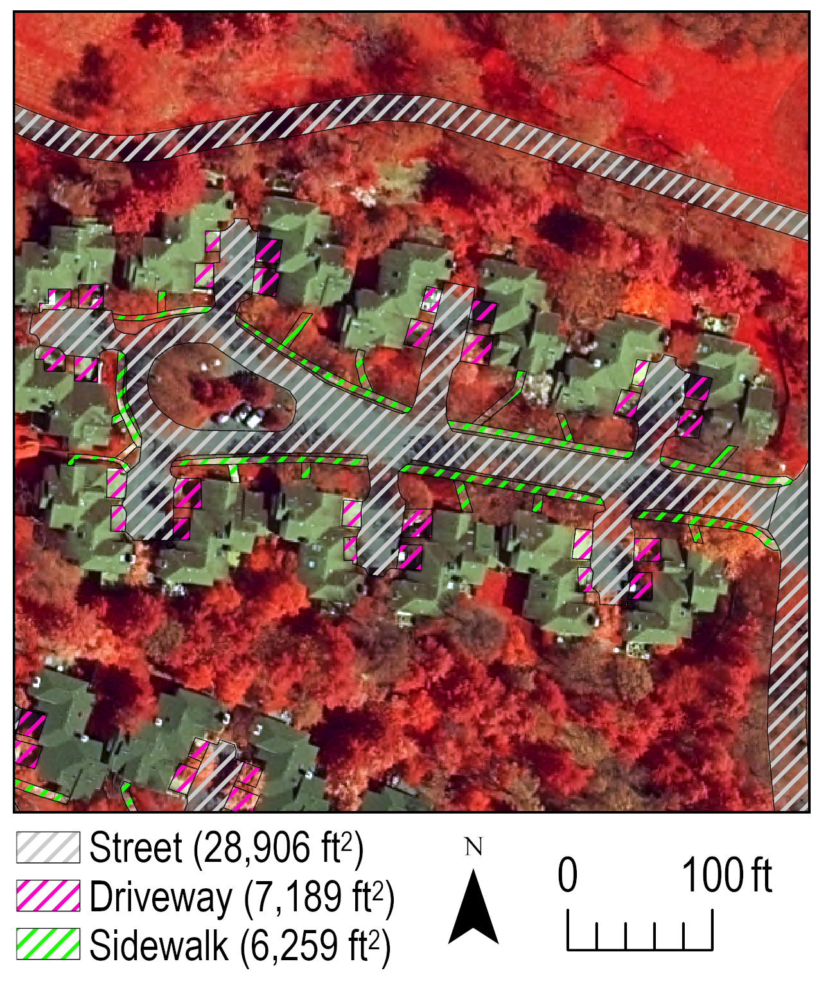

**Figure 9.** The extent (square feet in parentheses) of pavement in Princeton Landing parcel eight.

Parcel nine follows essentially the same design pattern as eight (Figure 10), except on two occasions at the far left (west) of the development two driveways could not be split as the planting strip separating driveways could not be discerned using aerial imagery nor verified by Google Street View, and hence the entire driveway area of these separate residences are combined into one without a separation afforded by a planting strip.

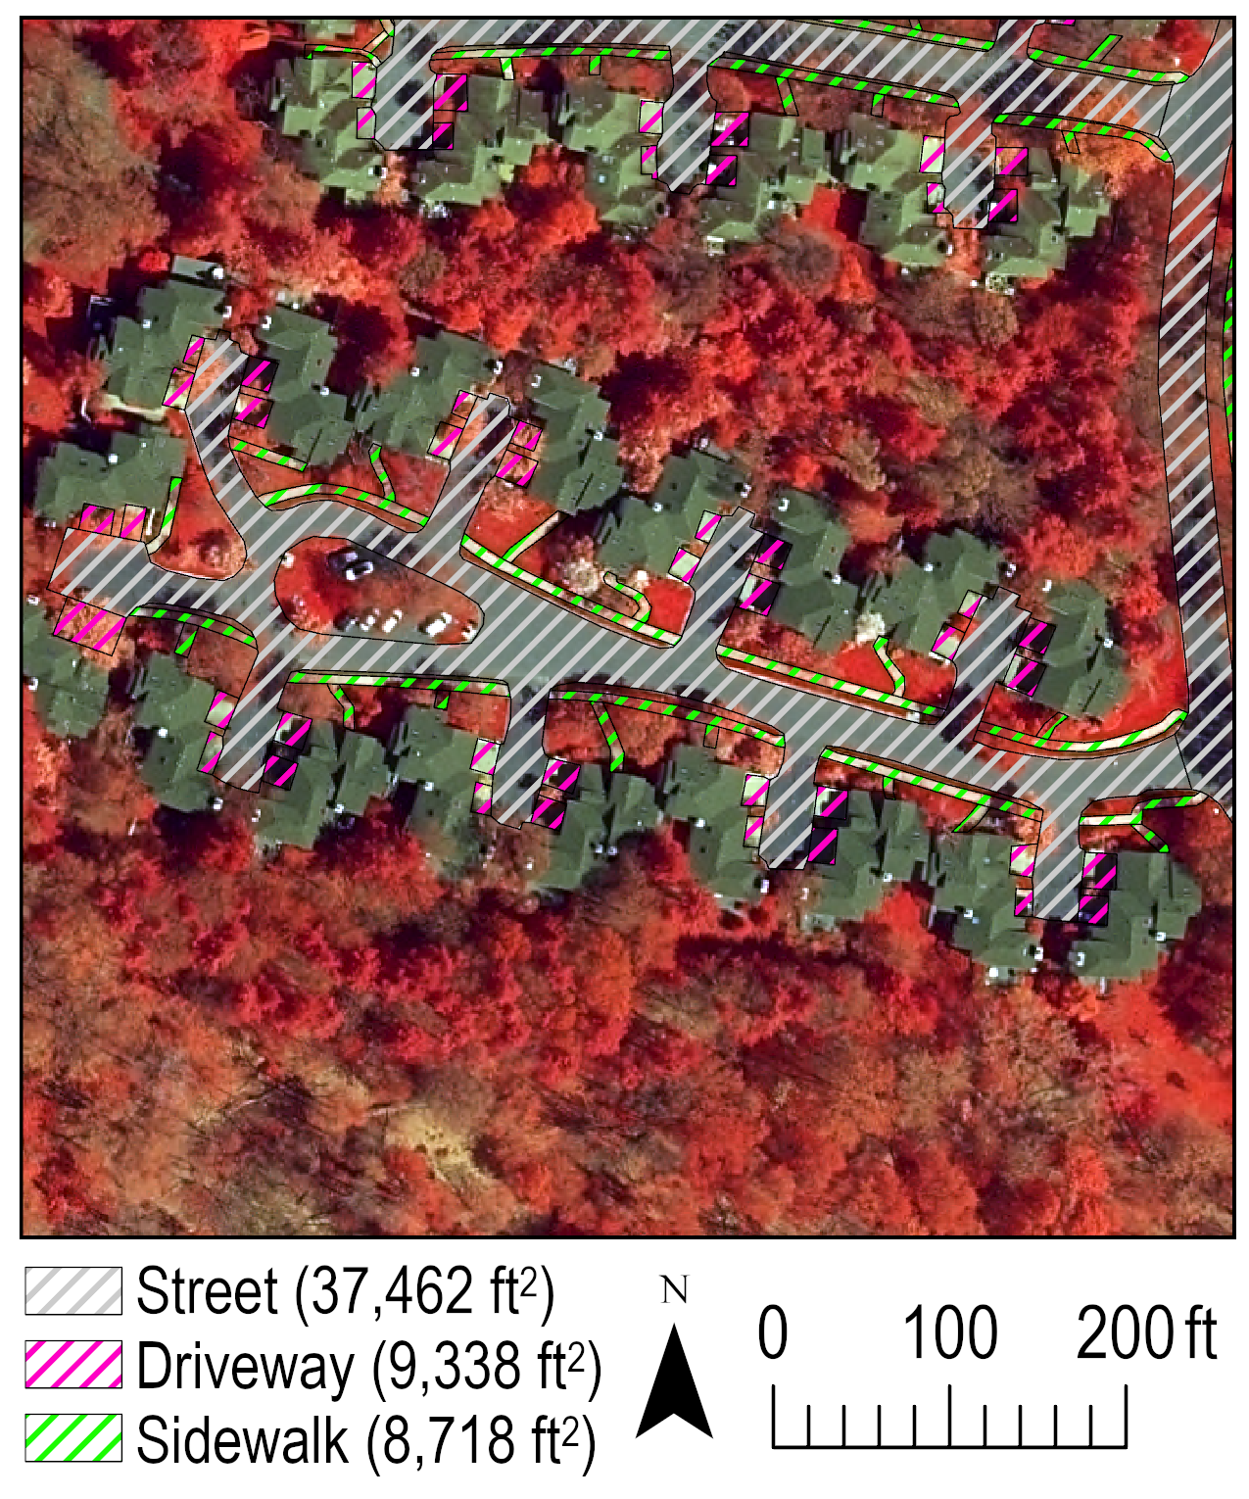

**Figure 10.** The extent (square feet in parentheses) of pavement in Princeton Landing parcel nine.

Parcel ten follows the design pattern of parcel five where a main street provides access to the loop road, and that main street provides access to driveways which lead to garages (Figure 11). Sidewalks ring the main street, connect driveways, and also connect driveways nearest to the loop road to the sidewalk of the loop road. Sidewalks also lead from driveways around the side of a residence to its doorway. This occurs for many residences, but not all, in particular those at the corner of a street where the driveway combines with a paved entryway into a doorway of the residence. There are some differences in this pattern in the part of parcel ten at the left (west), which follows the pattern of having inlet streets leading to driveways, and therefore these residences do not have sidewalks dedicated to accessing the doorway and rather the driveway has pavement that provides that access. The sidewalks of parcel ten that lead to the Smith House (to the north) are assigned to the Smith House as that is the function that they serve (i.e., providing access to the Smith House). For this reason, they are not deemed essential for snow plow services in parcel ten and they are assigned to the Smith House. This applies to the sidewalk farthest north which leads to the road that services the Smith House. Sidewalks and streets surrounding the Smith House and pool at the top (north) of Figure 11 are assigned to the Smith House and not essential for plowing in providing access to residences of Princeton Landing.

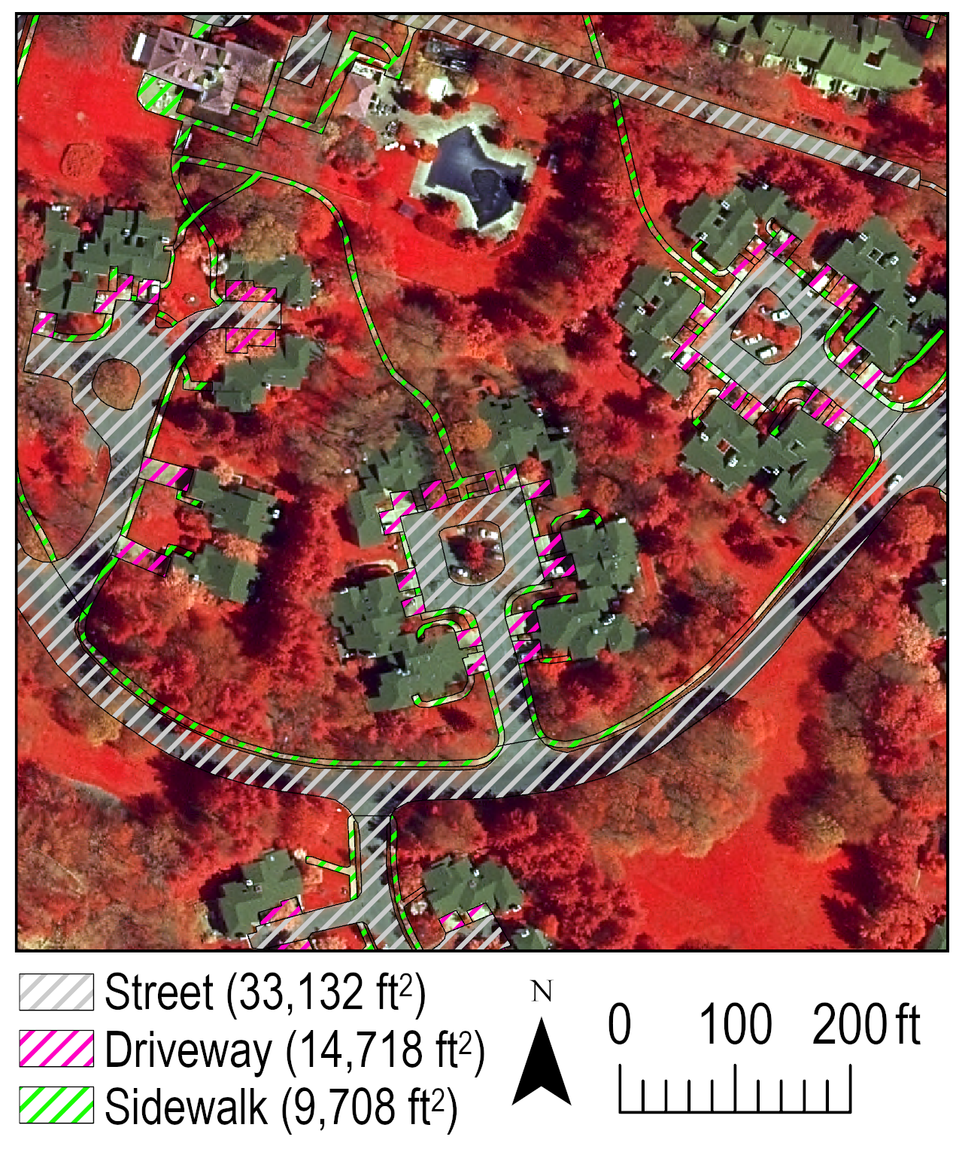

**Figure 11.** The extent (square feet in parentheses) of pavement in Princeton Landing parcel 10.

Parcel 11 follows the design pattern of other parcels where a main street leads to what is termed “inlet” streets that provide access to driveways (Figure 12). This deviates in that in parcel 11 it is not possible to distinguish the split between many of the driveways because of tree cover over much of the driveways and also because the inlet streets are longer in this parcel which prevents viewing the driveways in Google Street View. Therefore, driveways are assigned as one continuous unit serving what are two residences. This means that likely the area of driveways in parcel 11 is modestly overestimated, but not by much as the vegetated planting strips in other parcels of Princeton Landing are quite small in area. Sidewalks ring the main street providing access to inlet streets that proceed on to residences, and a select number of sidewalks provide access to residences, and these are mapped separately in case they need to be parsed from the larger dataset at a later time. The sidewalks of this parcel are entirely self-enclosed, and do not connect to a sidewalk on the loop road.

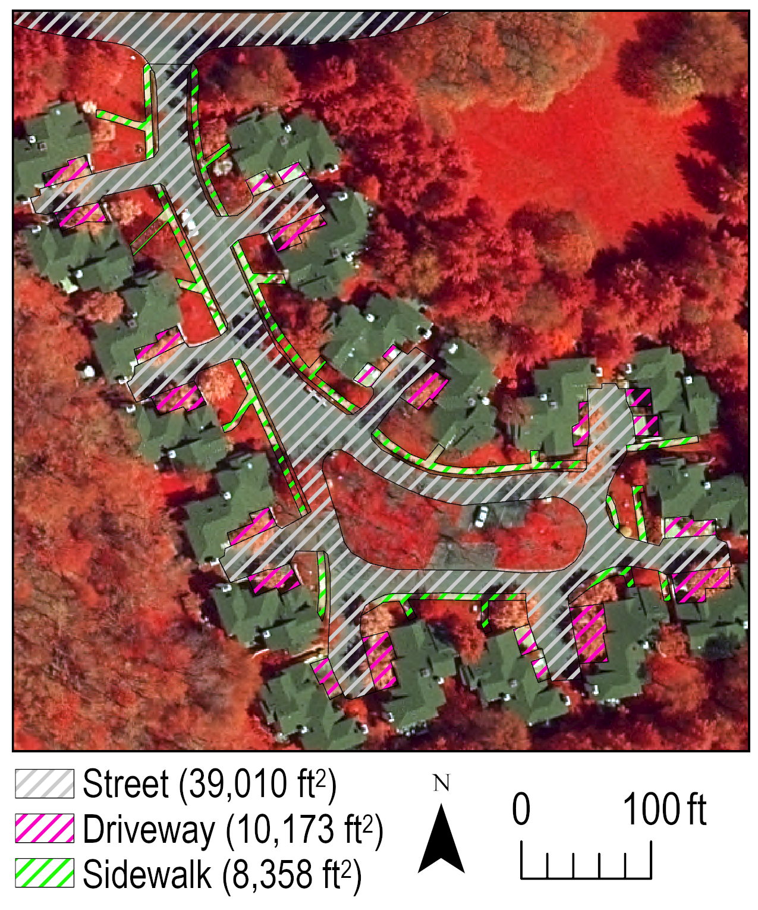

**Figure 12.** The extent (square feet in parentheses) of pavement in Princeton Landing parcel 11.

Parcel 12 follows a similar pattern as that previously described in parcel 11 (Figure 13). It also suffers from the same problem of not being able to distinguish planting strips between driveways of different residences, and therefore, driveways in most instances are treated as one continuous unit for two residences at “inlet” streets leading to the main street of the parcel. Sidewalks ring the main street of the parcel, and like parcel 11, sidewalks are self-enclosed and do no lead or connect to a sidewalk on the loop road. The small part of parcel 12 pictured at right of Figure 13 is of a somewhat different design pattern in that it takes the form of two “inlet” streets in which the connecting driveways cannot be distinguished by residence. Thus, they are treated as one continuous unit without a planting strip division. Sidewalks following the loop road of this part of parcel 12 are assigned to the loop road, but the sidewalks that lead into the small part of parcel 12 are assigned to the parcel as they lead directly to the residences of the parcel and provide this part of parcel 12 with wider access to the community.

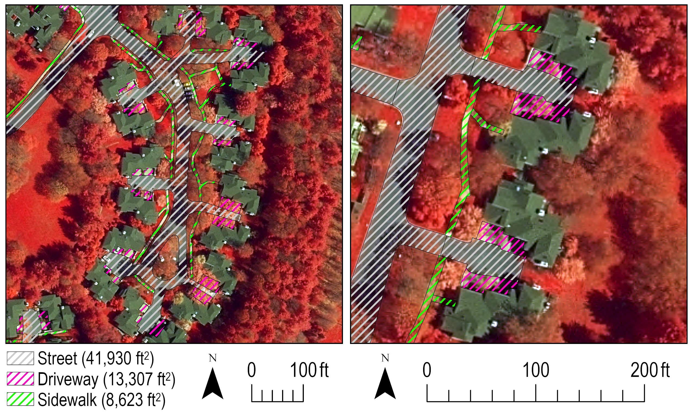

**Figure 13.** The extent (square feet in parentheses) of pavement in Princeton Landing parcel 12.

**Data Deliverable:**

The data as outlined in this final report maps the pavement of Princeton Landing, New Jersey divided between streets, driveways, and sidewalks with attributes indicating this (see the attribute named “Type”), what parcel the pavement is assigned (see the attribute named “Parcel”), and size in square feet of the particular unit of pavement (see the attribute named “Square_Feet” or “SquareFeet” depending on file format). The data are provided in various formats for use in different software depending on who the Association might like to use this data and what software they plan to use. For this reason, the data are provided in standard geographic information system mapping files, in the format of how the pavement is mapped here (i.e., a geodatabase feature class and copy of this in shapefile format for use outside of a geodatabase). From the geodatabase feature class, the file of pavement was exported to computer-aided design (CAD) file formats for engineering design uses (see CAD files in dxf and dwg file formats). Finally, for use in Google Earth is a kmz file which can be opened simply by double-clicking on that file on a machine that has Google Earth installed for free. The pavement statistics provided in Table 1 are duplicated in a spreadsheet (named “Pavement.xlsx”) for those who may want to perform calculations on that data. Each of these files can be downloaded by clicking the “Download raw file” button at:

<https://github.com/geoffreyfouad/Princeton_Landing/blob/main/Princeton_Landing.zip>

**Invoice:**

Geoffrey Fouad

305 E 24th St Apt 11U

New York, NY 10010

864-918-9799

geoffrey.fouad@gmail.com

INVOICE

|  |  |  |
| --- | --- | --- |
| **Bill To:**  Forrestal Village Community Services Association, Inc.  joe.prencipe@gmail.com  703-559-5154 | **Payment Method:**  PayPal payment to geoffrey.fouad@gmail.com | **Invoice No:** 1  **January 8, 2024** |

**Project:** Princeton Landing, New Jersey Pavement Mapping for Snow Plow Audit

|  |  |  |  |  |
| --- | --- | --- | --- | --- |
| **DATE** | **DESCRIPTION OF WORK** | **HOURS** | **RATE** | **SUBTOTAL** |
| 01/02 | Mapping of pavement in Princeton Landing as described in the methodology of the final report | 8 | $40/hr | $320 |
| 01/03 | Above continued | 8 | $40/hr | $320 |
| 01/04 | Quality control assessment of pavement mapping completed in the process of constructing figures and statistics for the final report | 2 | $40/hr | $80 |
| 01/05 | Compilation/writing of the final report and synthesis of results | 4 | $40/hr | $160 |
| 01/08 | Above continued | 3 | $40/hr | $120 |
| 01/08 | Packaging and documentation of final data deliverable | 2 | $40/hr | $80 |
|  |  |  | **TOTAL** | $1080 |

**Geoffrey Fouad, PhD**

Lecturer of Earth Science, Department of Geography and Environmental Science,

Hunter College, New York, NY 10065 USA

[geoffrey.fouad@hunter.cuny.edu](mailto:geoffrey.fouad@hunter.cuny.edu)

**Areas of Specialization**

I am a **geographer** who applies **geospatial methods** to study **environmental systems**.

**Education**

San Diego State University/UC Santa Barbara Ph.D. in Geography May 2016

University of South Florida M.S. in Environmental Science May 2009

University of South Florida Graduate Certificate in GIS May 2009

Catawba College B.S. in Environmental Science May 2006

**Recent Consulting**

The following consulting positions entail providing mapping services in various contexts, such as is required in the work conducted for Forrestal Village Community Services Association, Inc.

**New Jersey Historical Commission** September 2022-August 2023

[American Revolutionary War map investigation](https://drive.google.com/file/d/1nwctNnUYLOuZ7nHJy4e8smWGj_qdVbCN/view?usp=sharing) conducted for a grant managed by Kean University’s Dean of the College of Liberal Arts, Jonathan Mercantini ([jmercant@kean.edu](mailto:jmercant@kean.edu))

**Tampa Bay Water**  January 2019-October 2021

[Wetland discharge investigation](https://www.swfwmd.state.fl.us/sites/default/files/medias/documents/Palustrine-Wetlands-Report.pdf) conducted for a research contract administered by the University of South Florida Water Institute under the direction of Mark Rains ([mrains@usf.edu](mailto:mrains@usf.edu))

**National Park Service**  January 2021-September 2021

[Phase II archaeological survey](https://drive.google.com/file/d/1ABhwLkrouYe3Cz9eWqBu1UorNYpPcjI8/view?usp=sharing) conducted for a research contract managed by Monmouth University’s Provost for Academic Affairs, Richard Veit ([rveit@monmouth.edu](mailto:rveit@monmouth.edu))

**Suwannee River Water Management District** December 2018-January 2021

[Minimum flows and water levels investigation](https://www.mysuwanneeriver.com/DocumentCenter/View/17834/LSFIR-MFL-Report-Final) conducted under a consulting contract managed by the President of HSW Engineering, Inc., Ken Watson ([kwatson@verdantas.com](mailto:kwatson@verdantas.com))

**Tampa Bay Water**  August 2017-August 2018

[Wetland groundwater conditions investigation](https://www.swfwmd.state.fl.us/sites/default/files/medias/documents/Changes_Wetland_GW_Conditions_NTB_1990-2015%20%286%29.pdf) conducted under a consulting contract managed by the President of HSW Engineering, Inc., Ken Watson ([kwatson@verdantas.com](mailto:kwatson@verdantas.com))

**Recent Academic Appointments**

The following appointments entail teaching and research in mapping and environmental sciences requiring knowledge of the latest in technology relevant to the present work of this investigation.

Lecturer of Earth Science, August 2023-present

Hunter College, New York, USA

Tenured Professor of Geography, July 2022-August 2023

Monmouth University, New Jersey, USA

**Scope of Work**

Submitted by Geoffrey Fouad, PhD (“Consultant”)

Submitted to Forrestal Village Community Services Association, Inc. (“Association”)

Submitted for snow plow audit (pavement mapping)

**Rate:** The Consultant is proposing to engage the Association at a rate of $40 per hour

**Goal:** The goal of this work is to map pavement subdivided into streets, driveways, and sidewalks in 12 development parcels of the Princeton Landing community in Princeton, New Jersey for the purpose of a “snow plow audit” (i.e., a cost estimate for snow plow services in the community based on the area of pavement).

**Approach:** The general approach is one of using an aerial image of the community, and digitizing the pavement of the image in a geographic information system employing a coordinate system for an estimate of the area of pavement by parcel and total overall pavement for the whole community. The practice of digitizing the pavement is done here in three different ways at increasing cost and manual interventions (i.e., editing) for the Association to choose from in agreeing to proceed with this service (i.e., one of these methods will be applied to the whole community). The three methods are as follows:

1. Semi-automated in which the image is broken into segments (i.e., objects) and those objects are then binned by a support vector machine (SVM) classifier into classes that match the properties of training samples (i.e., this is what makes the process semi-automated because the training samples are mapped manually)
2. The classes from above are refined manually to more closely match pavement on the ground by way of human intuition (e.g., a sidewalk continues beneath street trees at the same width to connect two streets) and by verification with secondary data sources, including Google Maps, Street View, and engineering design plans supplied by the Association
3. The third approach is fully manual in digitizing (drawing) pavement based on what is visible in the imagery and extending that to follow predictable patterns of pavement beneath trees and in shadows while verifying this work by inspection of Google Maps, Street View, and engineering design plans supplied by the Association

**Work Sample:** The pavement of the small part of Parcel XII (12) is mapped following the above three approaches with total cost estimates for each approach. The Association can pick which approach they would like based on the results and the cost estimate. The small part of Parcel XII is delineated here according to State of New Jersey property parcel tax boundaries (Figure 1). This means pavement is mapped in the property parcels and that extends out following sidewalks in common areas (see the sidewalks traveling north and south out of Parcel XII). For accounting purposes, those extraneous sidewalks are coalesced into Parcel XII, but streets are terminated at the boundary of the tax property parcels. If the Association wants a different means of accounting by Association parcels, such as Parcel XII, then this will be discussed following the acceptance of this scope of work.

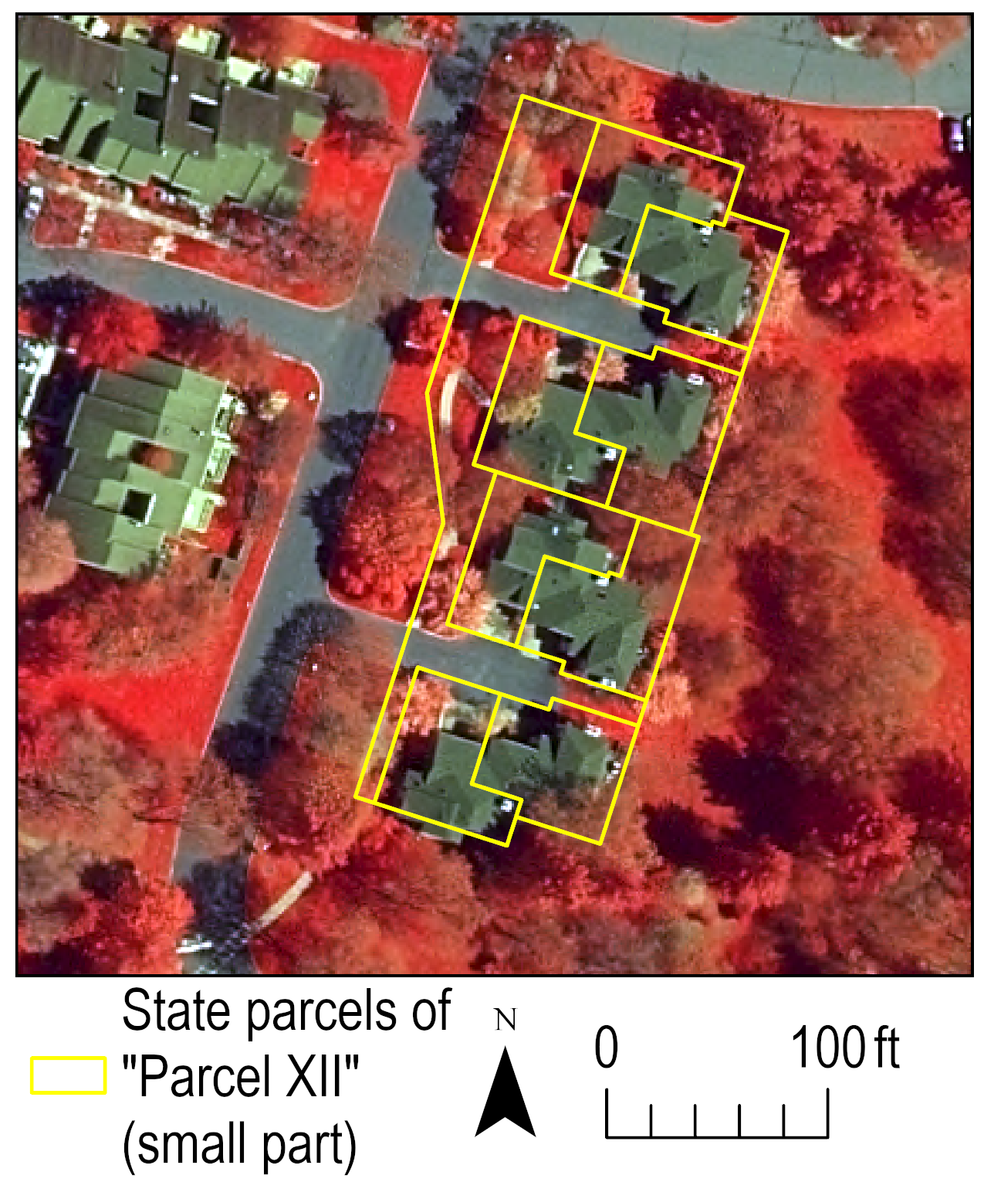

**Figure 1.** The small part of Parcel XII including the tax property parcels outlined in yellow and the sidewalk visibly extending into common areas south/north of the tax property parcels.

The semi-automated pavement classification results show that for accurate accounting purposes manual edits are likely required (Figure 2). In this classification, streets are confused for shadow (from trees), vegetation (tree canopy over street), and roofs as streets and roofs share similar spectral characteristics (i.e., they have similar colors). Driveway is largely absent in the classification as they are covered in shadow, and sidewalks are often covered in tree canopy and mistaken for vegetation. Despite these deficiencies, an advantage of this approach is that the entire community can be classified. In fact, at present, it is (work taking two hours), but this classification can be improved by adding more training samples for the semi-automated classification, which took about five minutes for Parcel XII. At that rate, extending training samples to the entire area of the community would take about three hours plus the two already invested in this approach for a total of five billable hours. Those five billable hours would then be included in the next approach of refining/editing the classes of the semi-automated approach.

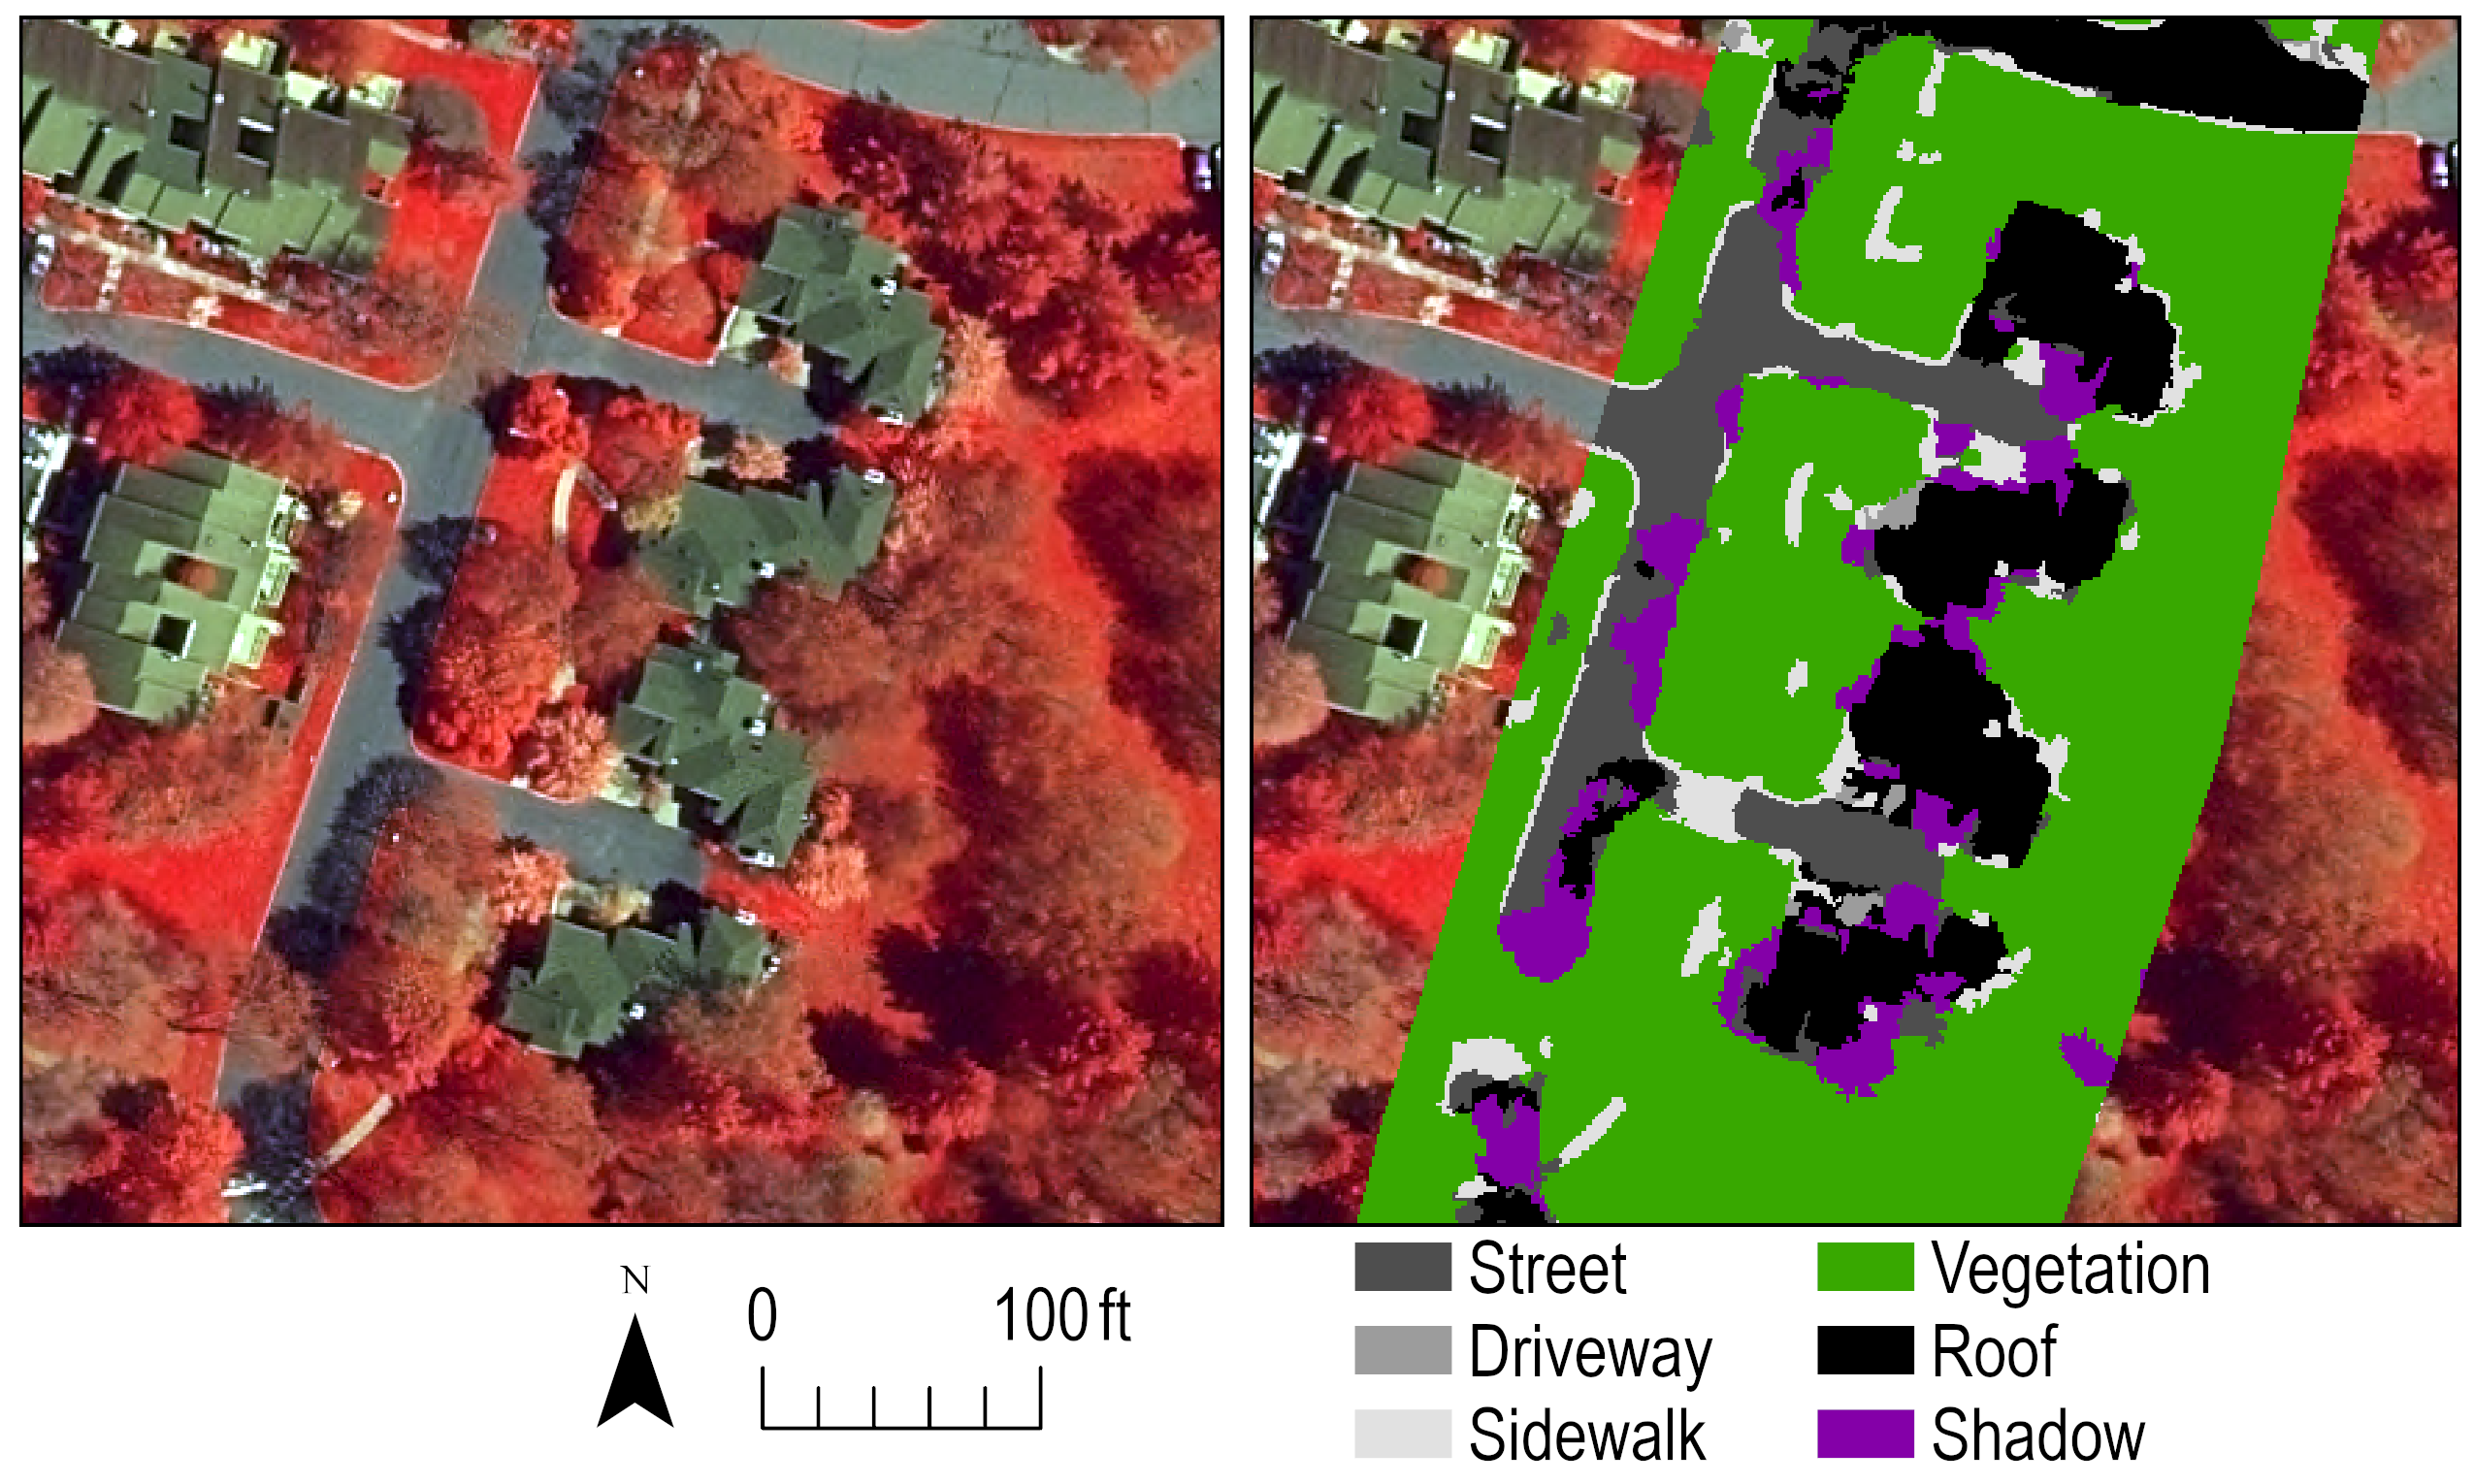

**Figure 2.** Semi-automated map of pavement in and around Parcel XII where only the pavement in the tax property parcels in Figure 1 and extending along sidewalks out of the tax property parcels are used in the final accounting numbers for Parcel XII.

In the second approach, the classes from the semi-automated map (Figure 2) are manually edited according to human intuition (e.g., sidewalks connecting streets under trees) and by verification with secondary data sources (Figure 3). The results here fix the problems previously outlined in the semi-automated classification of pavement, and the map reader can now see that streets are corrected to follow their paths beneath shadow and tree canopy, streets confused as roofs are corrected, driveways are inserted to enforce the topology that they are the area separating the street from the home front (in this particular neighborhood design), and sidewalks are continued under vegetation similar to streets. It is of note too that the size of sidewalks using this approach is likely to be overestimated even despite the edits as oftentimes curbs (light-colored) and other vegetation such as that around the sides of the roofs in Parcel XII (see Figure 2) are classified as sidewalks yet in neither case will snow plowing be applied (and thus this approach may overestimate plowing costs). The edits here were an additional 15 minutes, which scales according to the area of the community to about nine additional hours of editing, plus the five hours needed for the semi-automated approach, totaling 14 billable hours for this hybrid approach of refining/editing semi-automated classes.

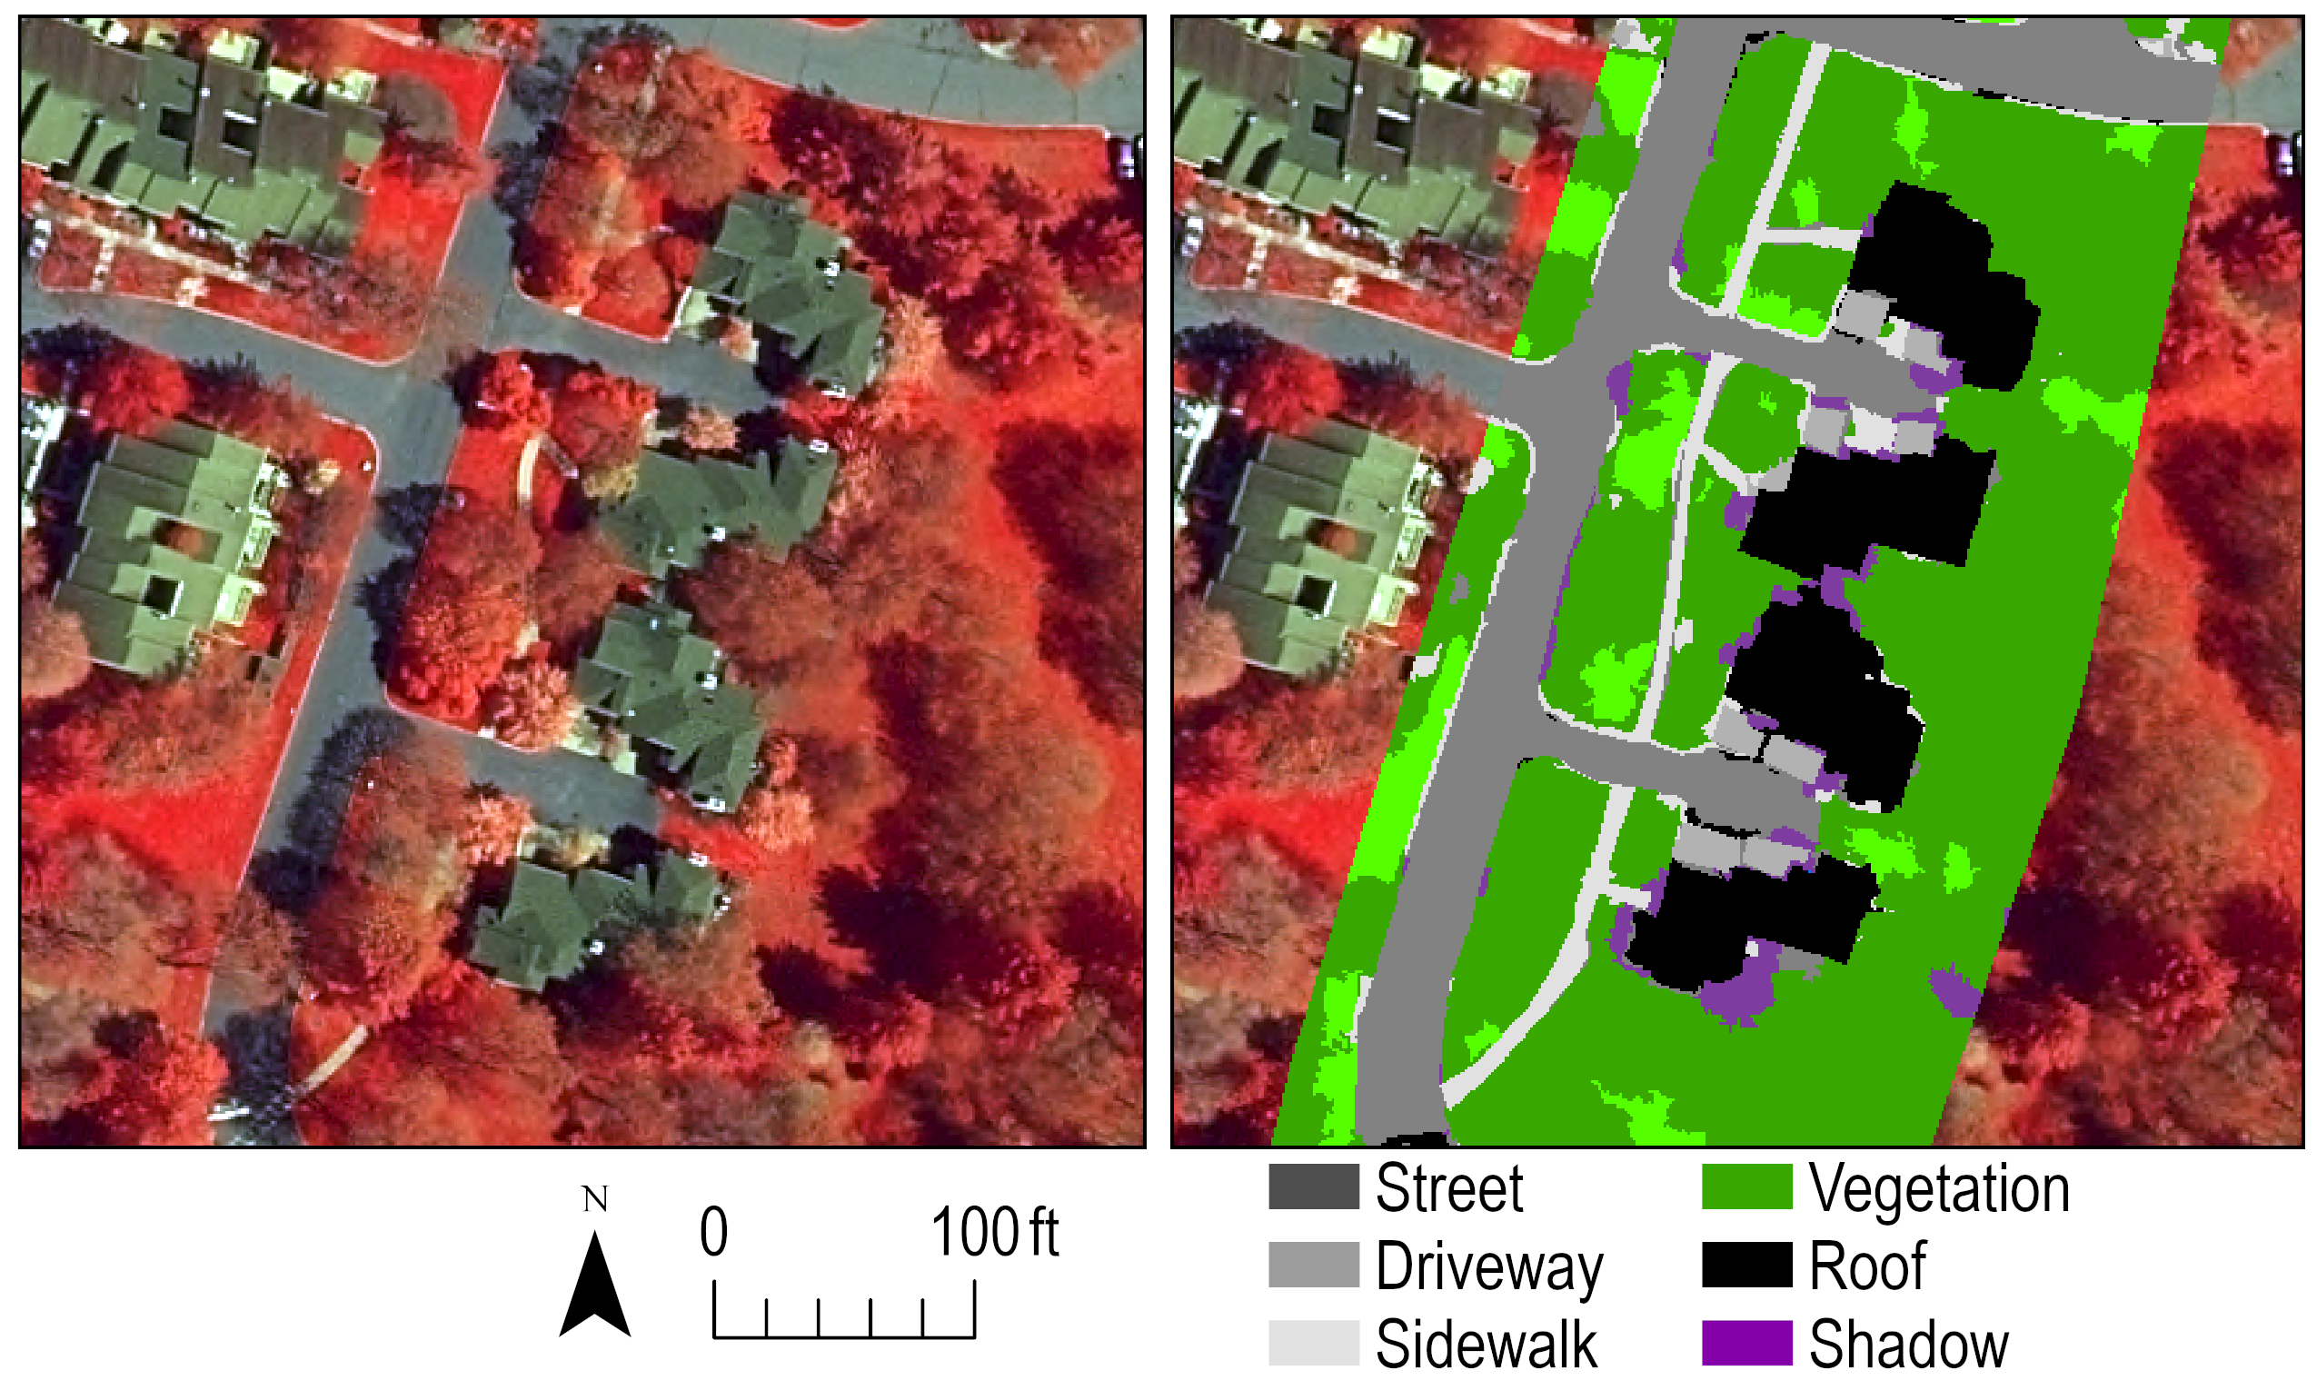

**Figure 3.** Edited pavement for the semi-automated classes mapped for the small part of Parcel XII where only areas inside the tax property parcels and the sidewalk extending from that in the north/south direction (see Figure 1) are used in the accounting of paved surfaces.

The third and final approach shows that the human defeats the machine in the present case of mapping paved surfaces in the aerial image (Figure 4). This is largely due to the enhancements that can be made from following patterns of where streets, driveways, and sidewalks travel regardless of the presence of overhanging vegetation and shadows in the image. The paved surfaces are further refined and verified by way of secondary sources, including Google Maps, Street View, and engineering design plans of the small part of Parcel XII supplied by the Association. This all functions to make the results of this approach more realistic than that achieved by the prior two approaches, and for that reason, despite the extra cost it is the opinion of the Consultant that this is the approach that should be adopted. It is also of note that the areal extent of pavement mapped in this approach will be conservative relative to the other two approaches because areas that are not pavement will not be mistakenly classified as pavement (i.e., errors of commission). This is another reason the Consultant recommends the manual approach in addition to it being more realistic. The extra cost of the approach is minimal as it only adds four hours on to the billable hours of the second approach for a grand total of 18 hours to manually map paved surfaces in the entire community. For the reasons outlined here, it is the recommendation of the Consultant that we proceed with this approach of manually mapping pavement according to what is visible in the aerial imagery and verification by way of secondary sources. This is the most rigorous and seemingly accurate approach to map pavement in this case.

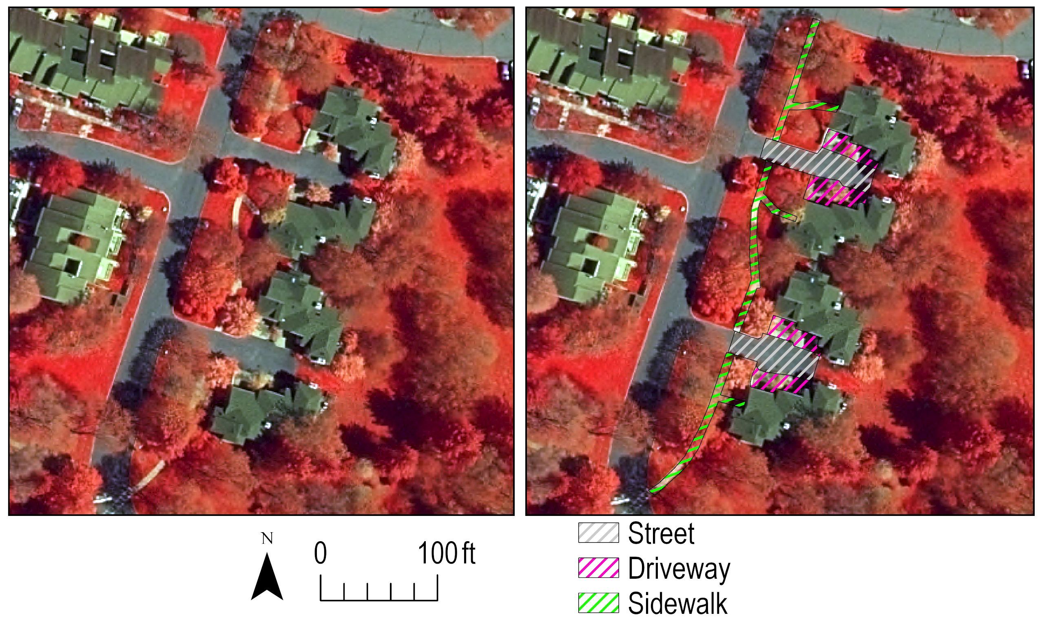

**Figure 4.** Manually mapped paved surfaces in the small part of Parcel XII showing that this approach produces the most realistic and perhaps most importantly a conservative estimate of the extent of paved surfaces relative to the other approach that involves editing (i.e., the second approach) in the tax property parcels of Parcel XII and the sidewalk extending north/south from that as depicted in Figure 1.

From each of the three approaches, an estimate of the coverage (square feet, i.e., ft2) can be made for the accounting area of Parcel XII (i.e., the area outlined in yellow in Figure 1 plus the sidewalk extending north/south of that). The estimates show that the manual approach is more realistic than the semi-automated approach in properly accounting for driveways (compare driveway extents in Table 1), and when it comes to a comparison of the two approaches involving manual edits, the fully manual approach is more conservative because areas that are not pavement are not misclassified as such. Therefore, it is the opinion of the Consultant that the manual approach be taken to complete this work for the entire community at approximately 0.2 square miles not to exceed 20 billable hours.

**Table 1.** Estimates of paved surfaces in square feet (ft2) subdivided into street, driveway, and sidewalk (see the rows) in the accounting area of Parcel XII (see Figure 1) including the sidewalk extending north/south of Parcel XII mapped by three methods (see the columns).

|  |  |  |  |
| --- | --- | --- | --- |
|  | Semi-automated | Semi-automated and edited | Manual |
| Street | 4,049 | 3,970 | 3,850 |
| Driveway | 447 | 2,071 | 3,015 |
| Sidewalk | 3,440 | 4,211 | 3,014 |
| Total | 7,936 | 10,252 | 9,879 |

**Cost Estimates:** The cost estimates are rationalized in the prior section and listed here as follows:

1. Semi-automated approach is estimated at five billable hours
2. The semi-automated approach plus edits is estimated not to exceed 15 billable hours
3. And, finally, the most rigorous/realistic approach is estimated not to exceed 20 billable hours

For the total number of billable hours for this entire project, please take your choice from the above options and add eight billable hours on to that in the preparation of a final report including statistics like that shown here (i.e., area of paved surface types by the Association Parcels and totals for the whole community), figures of mapping results by Association Parcel, and documentation of the data to be delivered by the Consultant to the Association in geographic information system geodatabase file format and computer-aided design coverages for the entire community and broken down by Association Parcel for individual analysis/use.

In summary, please choose from an option above for an estimate of billable hours and add to that eight hours in the completion of a report, documentation of data, and packaging of data for the Association. This means the corresponding cost estimates for each approach at a rate of $40 per hour are as follows:

1. Five hours plus eight hours equals 13 total hours ($520)
2. 15 hours plus eight hours equals 23 total hours ($920)
3. 20 hours plus eight hours equals 28 total hours ($1,120)

To begin this work in whatever plan the Association chooses, the Consultant requests an advance payment of $200 to be taken out of the final invoice. This way we can ensure that a method of payment is confirmed before commencing work and this accounts for the hours dedicated in preparing this detailed and complete scope of work.

For questions, please email the Consultant at [geoffrey.fouad@gmail.com](mailto:geoffrey.fouad@gmail.com) or call 864-918-9799.